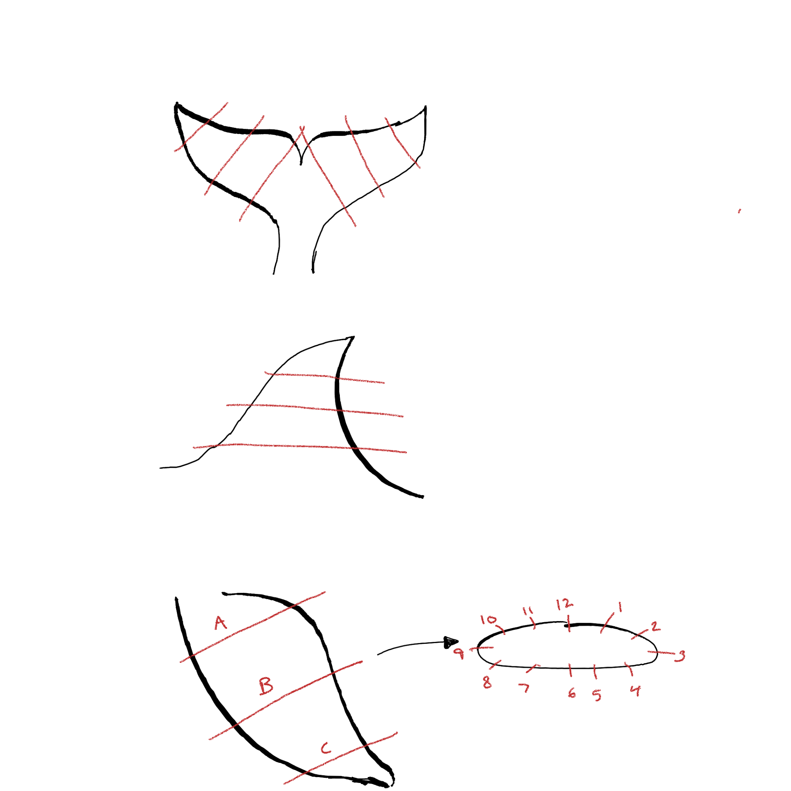

Right Pectoral Fin | A (mm) | B (mm) | C (mm)
1 | 4.24 | 1.69 | 0.21
2 | 1.90 | 0.76 | 0.12
3 | 2.22 | 6.21 | 2.47
4 | 1.77 | 1.01 | 0.64
5 | 1.28 | 0.66 | 0.69
6 | 7.22 | 1.27 | 0.33
7 | 2.25 | 0.44 | 0.45
8 | 1.79 | 0.90 | 1.07
9 | 3.43 | 1.42 | NA - scarring
10 | 1.39 | 0.57 | NA -scarring
11 | 5.44 | 0.62 | 0.45
12 | 6.54 | 4.89 | 0.72
Width at cut | 13cm | 14cm | 9cm

